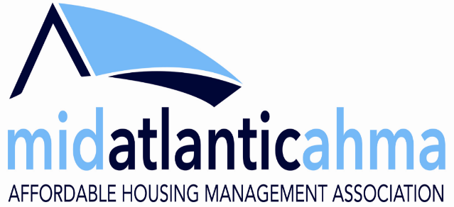

Photo/Video/Digital Media Release Waiver
I hereby grant the Mid-Atlantic AHMA permission to use my likeness in a photograph, video, or other digital media in any and all its publications, including web-based publications, without payment or other consideration.
I understand and agree that all photos, videos or other digital media will become the property of the Mid-Atlantic AHMA and will not be returned.
I hereby irrevocably authorize the Mid-Atlantic AHMA to edit, alter, copy, publish, or distribute these photos, videos or other digital media for any lawful purpose. In addition, I waive any right to inspect or approve the finished product wherein my likeness appears. Additionally, I waive any right to royalties or other compensation arising or related to the use of the photo, video or other digital media.
I hereby hold harmless, release, and forever discharge the Mid-Atlantic AHMA from all claims, demands, and causes of action which I, my heirs, representatives, executors, administrators, or any other persons acting on my behalf or on behalf of my estate have or may have by reason of this authorization.
I HAVE READ AND UNDERSTAND THE ABOVE PHOTO RELEASE. I AFFIRM THAT I AM AT LEAST 18 YEARS OF AGE, OR, IF I AM UNDER 18 YEARS OF AGE, I HAVE OBTAINED THE REQUIRED CONSENT OF MY PARENT/GUARDIAN AS EVIDENCED BY THEIR SIGNATURE BELOW. I ACCEPT:
Print Name: ______________________________
(Of person pictured)
Signature: ______________________________ | Date: __ / __ / ____
If under 18, a parent must sign individually (above) and as parent/guardian (below).
Parent Signature: ______________________________ | Date: __ / __ / ____
Print Parent Name:___________________________________

