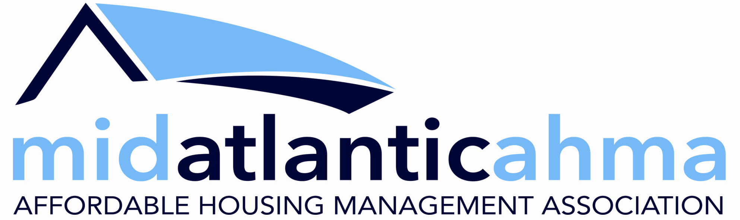 | 909 Westham Pkwy.; Richmond, VA 23229  Ph. 804-673-4128; Fax 904-673-4129  Return to: help@mid-atlanticahma.org

Board Application Form
Name |  | Position/Title
Company |  | Phone/Fax

Complete Mailing Address

Email Address

Date
Thank you for your interest in serving on the Mid-Atlantic AHMA Board of Directors. To help us get to know you, please complete this form by responding to each question fully (use as much space as needed to answer fully). Once completed, please return to Terry Doherty Rice, Executive Director, at terry@mid-atlanticahma.org. She will forward your application for review by the full Board. Please keep in mind that Board meetings are typically held in Richmond on the 3rd Monday of January, April and July with a fourth meeting scheduled in early December. Directors are expected to participate in each meeting; many meetings are now held via zoom but some in-person meetings may resume in 2023. The ability and willingness to devote time between meetings is also expected.

How familiar are you with the Mid-Atlantic AHMA mission and services? Explain your/your company’s experiences with and understanding of our mission/services.

Why are you interested in serving on the AHMA Board?

Is your request to serve on the AHMA Board approved and sanctioned by your Company? Explain.

Will your schedule and responsibilities conflict with attendance and participation in board meetings in Richmond?

How much time can you devote to the MA-AHMA on a daily, weekly and/or monthly basis?

How well do you think you can represent the needs and concerns of housing professionals in your geographical area? Your State? How well do you know management executives outside your own company? (Please respond fully and be specific)

The Mid-Atlantic AHMA is specifically looking to expand our membership and services in the Maryland-DC-West Virginia markets. Please explain how you can contribute to that effort.

Describe your relationship with regulatory representatives that regulate your area? (Be specific)

What role do you think you will want to be most active in on the Board? i.e., identify any specific interests you might have.

How do you feel your experience, position, or knowledge/skills would benefit the AHMA Board and organization? Please be specific.

Please identify other association or organization boards on which you are serving or have served.

Please identify what you would consider the Mid-Atlantic AHMA’s greatest strength and greatest weakness and explain how you would build upon the strength and address the weakness.

